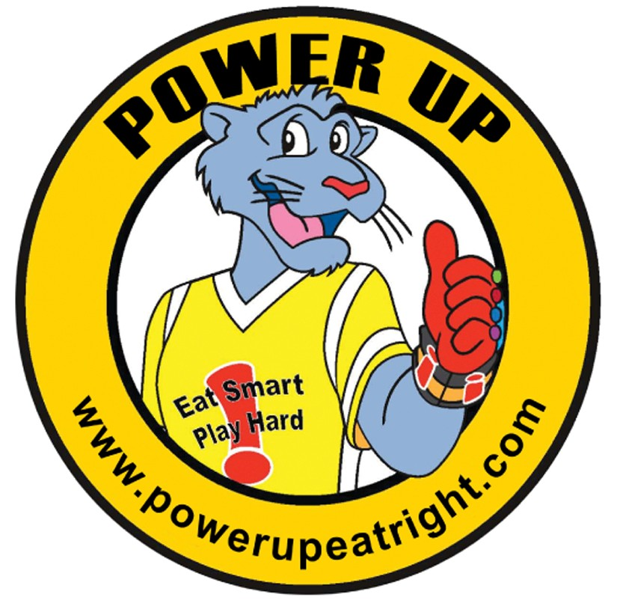
Power Up Panther Pause
Nutrition Tip: Make half your plate fruits and vegetables.
Activity: Fruits and veggies grow from seeds. Have students form a circle and crouch down (seeds in the ground), then slowly sprout and grow (slowly stretch to a standing position), eventually flowering towards the sun (tippy toes, arms outstretched). Repeat 5 times, getting faster each time, leading eventually to seeds in unison jumping into the air. Optional: Have children let out a sigh of relief when they stretch to the top, getting louder each time.
A) MyPlate/MyPyramid/MP for kids K-2
This material was funded by the PENNSYLVANIA NUTRITION EDUCATION TRACKS, a part of USDA’s Supplemental Nutrition Assistance Program (SNAP). To find out how SNAP can help you buy healthy foods, contact the PA Department of Public Welfare’s toll-free Helpline at 800-692-7462. This institution is an equal opportunity provider and employer
Power Up Panther Pause
Nutrition Tip: Fruits and vegetables are naturally low in calories.

Activity: Divide the class into 4 groups. Have each group move into a corner of the room and form a line. Give each group a fruit name such as apples, oranges, bananas, and watermelon. Call two of the fruit names and have the first student in those groups hop across the room to change places. The student then goes to the back of his or her new line and it becomes the next student’s turn. Once everyone has had a turn, yell “Fruit Basket” and return to seats.
A) MyPlate/MyPyramid/MP for kids K-2
This material was funded by the PENNSYLVANIA NUTRITION EDUCATION TRACKS, a part of USDA’s Supplemental Nutrition Assistance Program (SNAP). To find out how SNAP can help you buy healthy foods, contact the PA Department of Public Welfare’s toll-free Helpline at 800-692-7462. This institution is an equal opportunity provider and employer
Power Up Panther Pause
Nutrition Tip: Fruits and veggies are rich in vitamins and minerals that help the body feel healthy and energized.
Activity: Hopefully everyone ate their fruits and veggies today because energy is needed for the following activities.
- Hop on one foot while counting to 20
- Reach up high and then bend to touch toes 10 times
- Twist the torso back and forth while counting to 10

A) MyPlate/MyPyramid/MP for kids K-2

This material was funded by the Pennsylvania Nutrition Education Tracks, a part of USDA’s Supplemental Nutrition Assistance Program (SNAP). To find out how SNAP can help you buy healthy foods, contact the PA Department of Public Welfare’s toll-free Helpline at 800-692-7462. This institution is an equal opportunity provider and employer
Power Up Panther Pause
Nutrition Tip: Fruits are fun to eat! Some crunch, some squirt, some you peel… some you don’t, and some grow right in the backyard!
Activity: Lead students on an imaginary tour of an apple orchard. Bend down and pick up your apple basket. Now fill your basket by reaching up and picking 10 red apples. Bend down and pick up another apple basket. Now fill your basket by reaching up and picking 10 yellow apples. Repeat with green apples.
A) MyPlate/MyPyramid/MP for kids K-2

This material was funded by the Pennsylvania Nutrition Education Tracks, a part of USDA’s Supplemental Nutrition Assistance Program (SNAP). To find out how SNAP can help you buy healthy foods, contact the PA Department of Public Welfare’s toll-free Helpline at 800-692-7462. This institution is an equal opportunity provider and employer
Power Up Panther Pause
Nutrition Tip: Fruits and vegetables provide dietary fiber. Dietary fiber helps to keep the heart healthy, keep food moving through the body, and keep the stomach feeling full.
Activity: How about some Fruit and Veggie Hokey Pokey! Have students stand in a large circle and put their carrot stick in (extend left arm to center of circle), put their carrot stick out (remove arm), put their carrot stick in and shake it all about (shake arm). Do the Hokey Pokey (put arms up and wiggle fingers), turn themselves about (turn around) and clap while saying “that’s what it’s all about”. Repeat using right arm (green beans), left leg (bananas) & right leg (broccoli).

A)MyPlate/MyPyramid/MP for kids K-2

This material was funded by the Pennsylvania Nutrition Education Tracks, a part of USDA’s Supplemental Nutrition Assistance Program (SNAP). To find out how SNAP can help you buy healthy foods, contact the PA Department of Public Welfare’s toll-free Helpline at 800-692-7462. This institution is an equal opportunity provider and employer
Power Up Panther Pause
Nutrition Tip: Veggies dipped in a hummus or bean spread make a great protein-filled snack.
Activity: Time to do the hummus dip. Have students stand with hands on hips. Bend left knee while extending right foot/leg forward return to standing position. Bend right knee while extending left foot/leg forward. Return to standing position. Repeat several times getting faster each time.
A) MyPlate/MyPyramid/MP for kids K-2

This material was funded by the Pennsylvania Nutrition Education Tracks, a part of USDA’s Supplemental Nutrition Assistance Program (SNAP). To find out how SNAP can help you buy healthy foods, contact the PA Department of Public Welfare’s toll-free Helpline at 800-692-7462. This institution is an equal opportunity provider and employer
Power Up Panther Pause
Nutrition Tip: Veggies dipped in a hummus or bean spread make a great protein-filled snack.
Activity: Time to do the hummus dip. Have students stand with hands on hips. Bend left knee while extending right foot/leg forward. Return to standing position. Bend right knee while extending left foot/leg forward. Return to standing position. Repeat several times getting faster each time.
A) MyPlate/MyPyramid/MP for kids K-2

This material was funded by the Pennsylvania Nutrition Education Tracks, a part of USDA’s Supplemental Nutrition Assistance Program (SNAP). To find out how SNAP can help you buy healthy foods, contact the PA Department of Public Welfare’s toll-free Helpline at 800-692-7462. This institution is an equal opportunity provider and employer
Power Up Panther Pause
Nutrition Tip: 1 cup of 100% orange, apple, grape, or grapefruit juice counts as a fruit serving.
Activity: Have the students imagine they are swimming through a pool of 100% fruit juice. Start by having the students hold their noses while jumping into the pool. Have them swim a lap or two doing the freestyle stroke. Then, try the back stroke. When they get out of the pool, have them pretend to dry off with a towel. Repeat if you wish.
A) MyPlate/MyPyramid/MP for kids K-2

This material was funded by the Pennsylvania Nutrition Education Tracks, a part of USDA’s Supplemental Nutrition Assistance Program (SNAP). To find out how SNAP can help you buy healthy foods, contact the PA Department of Public Welfare’s toll-free Helpline at 800-692-7462. This institution is an equal opportunity provider and employer
Power Up Panther Pause
Nutrition Tip: Some beans and peas are part of both the Vegetable and Protein food groups.

Activity: Have students act like the following beans and peas:
- Jumping bean – jump around the room
- Lima bean – stretch arms and legs as wide as possible while walking around room
- Snap pea - stretch hands above head and snap fingers
- Chili bean – shiver and shake
- Bean sprout – crouch down and slowly stretch upwards until standing on tiptoes
A) MyPlate/MyPyramid/MP for kids K-2

This material was funded by the Pennsylvania Nutrition Education Tracks, a part of USDA’s Supplemental Nutrition Assistance Program (SNAP). To find out how SNAP can help you buy healthy foods, contact the PA Department of Public Welfare’s toll-free Helpline at 800-692-7462. This institution is an equal opportunity provider and employer
Power Up Panther Pause
Nutrition Tip: Rinse fruits and vegetables before preparing or eating them.

Activity: Let’s use some of the energy we get from eating fruits and vegetables and try a shoulder stretch. Stand with arms outstretched and thumbs pointing down. Gently push arms back as if you are squeezing a ball between your shoulder blades. Hold the stretch for 10 seconds, take a 5 second break in between, and repeat cycle 2 more times. Then, since the students have their arms outstretched, have them do 5 arm circles forward and 5 arm circles backwards.

A) MyPlate/MyPyramid/MP for kids K-2

This material was funded by the PENNSYLVANIA NUTRITION EDUCATION TRACKS, a part of USDA’s Supplemental Nutrition Assistance Program (SNAP). To find out how SNAP can help you buy healthy foods, contact the PA Department of Public Welfare’s toll-free Helpline at 800-692-7462. This institution is an equal opportunity provider and employer
Power Up Panther Pause
Nutrition Tip: Store leftovers in the refrigerator where the cool temperature slows the growth of germs and bacteria.
Activity: Let’s put leftovers in the refrigerator. Stand with legs slightly apart. Bend over and reach between legs to pick up leftovers and stretch toward the ceiling to put them on the refrigerator shelf. Repeat several times naming a food that should be stored in the refrigerator each time.

A) MyPlate/MyPyramid/MP for kids K-2

This material was funded by the PENNSYLVANIA NUTRITION EDUCATION TRACKS, a part of USDA’s Supplemental Nutrition Assistance Program (SNAP). To find out how SNAP can help you buy healthy foods, contact the PA Department of Public Welfare’s toll-free Helpline at 800-692-7462. This institution is an equal opportunity provider and employer
Power Up Panther Pause
Nutrition Tip: The best way to make sure meat is cooked is by using a meat thermometer.
Activity: A thermometer measures the rise and fall of temperature. Let’s stretch the calf muscles by slowing rising up and down on the balls of the feet. Call out “hot” and rise up on the ball of feet. Call out “cold” and return to a standing position. Alternate the amount of time students hold the “hot” stretch. Rest and repeat.

A) MyPlate/MyPyramid/MP for kids K-2
This material was funded by the PENNSYLVANIA NUTRITION EDUCATION TRACKS, a part of USDA’s Supplemental Nutrition Assistance Program (SNAP). To find out how SNAP can help you buy healthy foods, contact the PA Department of Public Welfare’s toll-free Helpline at 800-692-7462. This institution is an equal opportunity provider and employer
Power Up Panther Pause
Nutrition Tip: When washing hands follow these steps:
- Step 1) Wet hands with warm water
- Step 2) Add soap to hands
- Step 3) Rub hands together, between fingers, under fingernails, and on top of hands for 20 seconds (length of the ABC song)
- Step 4) Rinse all the soap off hands with warm water
- Step 5) Dry both hands with a paper towel and throw towel away

Activity: March in place while rubbing your hands together, as if washing them, and singing the ABC song.

A) MyPlate/MyPyramid/MP for kids K-2

This material was funded by the PENNSYLVANIA NUTRITION EDUCATION TRACKS, a part of USDA’s Supplemental Nutrition Assistance Program (SNAP). To find out how SNAP can help you buy healthy foods, contact the PA Department of Public Welfare’s toll-free Helpline at 800-692-7462. This institution is an equal opportunity provider and employer
Power Up Panther Pause
Nutrition Tip: Protein helps build strong muscle.
Activity: Let’s use our muscles. Split students into two groups on opposite sides of the room. Have each group form a single file line. Have the first student, in each line, do the crab walk to the other side of the room. Once the first students have reached halfway, the next students can start. As the students reach the opposite side of the room, have them go back to their seat.

A) MyPlate/MyPyramid/MP for kids K-2

This material was funded by the PENNSYLVANIA NUTRITION EDUCATION TRACKS, a part of USDA’s Supplemental Nutrition Assistance Program (SNAP). To find out how SNAP can help you buy healthy foods, contact the PA Department of Public Welfare’s toll-free Helpline at 800-692-7462. This institution is an equal opportunity provider and employer
Power Up Panther Pause
Nutrition Tip: All meat, poultry, seafood, dry beans and peas, eggs, nuts, and seeds are considered part of the Protein Food Group.

Activity: Try the following Protein Group exercises:
- Chicken Wings - flap arms like flying
- Rib Stretch - raise left arm & stretch to right side, raise right arm & stretch to left side
- Crab Walk - across the room
- Egg Scramble - switch places with another student
- Peanut Butter Slide - slide to the right then slide to the left

A) MyPlate/MyPyramid/MP for kids K-2
his material was funded by the PENNSYLVANIA NUTRITION EDUCATION TRACKS, a part of USDA’s Supplemental Nutrition Assistance Program (SNAP). To find out how SNAP can help you buy healthy foods, contact the PA Department of Public Welfare’s toll-free Helpline at 800-692-7462. This institution is an equal opportunity provider and employer
Power Up Panther Pause
Nutrition Tip: Choose lean or low-fat protein foods.
Activity: Lean on one foot, lift the other foot, and with hands on hips, balance. See who can balance the longest. Try the opposite foot.

A) MyPlate/MyPyramid/MP for kids K-2

This material was funded by the PENNSYLVANIA NUTRITION EDUCATION TRACKS, a part of USDA’s Supplemental Nutrition Assistance Program (SNAP). To find out how SNAP can help you buy healthy foods, contact the PA Department of Public Welfare’s toll-free Helpline at 800-692-7462. This institution is an equal opportunity provider and employer
Power Up Panther Pause
Nutrition Tip: Nuts, peanut butter, pumpkin seeds, and sunflower seeds, are all part of the protein group.
Activity: Let’s feed the elephants! Have the students bend over and put their hands together to form a “trunk”. Have them swing their trunks while walking about the room. When you yell “peanuts” the students freeze, stand and raise their trunks above their heads. Repeat several times.

A) MyPlate/MyPyramid/MP for kids K-2
This material was funded by the PENNSYLVANIA NUTRITION EDUCATION TRACKS, a part of USDA’s Supplemental Nutrition Assistance Program (SNAP). To find out how SNAP can help you buy healthy foods, contact the PA Department of Public Welfare’s toll-free Helpline at 800-692-7462. This institution is an equal opportunity provider and employer
Power Up Panther Pause
Nutrition Tip: Eggs are a great protein source to eat in the morning for breakfast.
Activity: Scrambled Eggs! Divide the class into 4 groups. Have each group move into a corner of the room and form a line. Assign each group a color (Easter eggs). Call two of the colors and have the students in those groups “scramble” to change places and form a new line. Repeat several times using different color combinations.

A) MyPlate/MyPyramid/MP for kids K-2
This material was funded by the PENNSYLVANIA NUTRITION EDUCATION TRACKS, a part of USDA’s Supplemental Nutrition Assistance Program (SNAP). To find out how SNAP can help you buy healthy foods, contact the PA Department of Public Welfare’s toll-free Helpline at 800-692-7462. This institution is an equal opportunity provider and employer
Power Up Panther Pause
Nutrition Tip: Switch to fat-free (skim) or low-fat (1%) milk.
Activity: Have the students do 10 lunges. Each time they lunge have them pretend to pick up a glass of milk and drink it. Take a 10 second break and repeat.

A) MyPlate/MyPyramid/MP for kids K-2

This material was funded by the PENNSYLVANIA NUTRITION EDUCATION TRACKS, a part of USDA’s Supplemental Nutrition Assistance Program (SNAP). To find out how SNAP can help you buy healthy foods, contact the PA Department of Public Welfare’s toll-free Helpline at 800-692-7462. This institution is an equal opportunity provider and employer
Power Up Panther Pause
Nutrition Tip: Milk, ice cream, string cheese, cottage cheese, and yogurt are all foods in the Dairy Food Group.
Activity: Have students do the following Dairy Group Moves:
- Milk March - march in place
- Ice Cream Scoop - bend at waist and scoop ice cream
- String Cheese Stretch - stand on tiptoes, extend arms toward ceiling
- Yogurt Yo-Yo - jump up and down

A) MyPlate/MyPyramid/MP for kids K-2

This material was funded by the PENNSYLVANIA NUTRITION EDUCATION TRACKS, a part of USDA’s Supplemental Nutrition Assistance Program (SNAP). To find out how SNAP can help you buy healthy foods, contact the PA Department of Public Welfare’s toll-free Helpline at 800-692-7462. This institution is an equal opportunity provider and employer
Power Up Panther Pause
Nutrition Tip: Dairy foods are a good source of calcium. Calcium helps to build strong bones.
Activity: Have students review some of the bones in the body.
- Ankle Bone - sit and roll ankles
- Knee Bone - stand and do knee bends
- Spine - stand and bend over and touch toes
- Skull - slowly roll head

A) MyPlate/MyPyramid/MP for kids K-2
This material was funded by the PENNSYLVANIA NUTRITION EDUCATION TRACKS, a part of USDA’s Supplemental Nutrition Assistance Program (SNAP). To find out how SNAP can help you buy healthy foods, contact the PA Department of Public Welfare’s toll-free Helpline at 800-692-7462. This institution is an equal opportunity provider and employer
Power Up Panther Pause
Nutrition Tip: Chocolate, strawberry and vanilla milk have the same amount of calcium as white milk. Flavored milk contains more sugar than white milk.
Activity: Have the students who like chocolate milk pretend to jump rope while counting to ten. Repeat with students who like strawberry, vanilla and white milk.

A) MyPlate/MyPyramid/MP for kids K-2

This material was funded by the PENNSYLVANIA NUTRITION EDUCATION TRACKS, a part of USDA’s Supplemental Nutrition Assistance Program (SNAP). To find out how SNAP can help you buy healthy foods, contact the PA Department of Public Welfare’s toll-free Helpline at 800-692-7462. This institution is an equal opportunity provider and employer
Power Up Panther Pause
Nutrition Tip: Whole grains provide fiber and energy for the body.

Activity: Let’s use some energy! Have the students do the following activities:
- 10 Jumping Jacks
- 10 High Knee Lifts
- 10 Jumping Jacks
- 10 Arm Circles
- 10 Jumping Jacks

A) MyPlate/MyPyramid/MP for kids K-2
This material was funded by the PENNSYLVANIA NUTRITION EDUCATION TRACKS, a part of USDA’s Supplemental Nutrition Assistance Program (SNAP). To find out how SNAP can help you buy healthy foods, contact the PA Department of Public Welfare’s toll-free Helpline at 800-692-7462. This institution is an equal opportunity provider and employer
Power Up Panther Pause
Nutrition Tip: Popcorn is a whole grain!
Activity: Pop some popcorn! Have the students form a large circle. Ask students to crouch into a ball (kernel of popcorn) and select one student to start “popping”. The student selected to go first will slowly stand up and jump. As the first student jumps, the student to his/her left will slowly stand and jump. This will continue around the circle until all the students have had a turn. Repeat several times at an increasingly faster pace.

A) MyPlate/MyPyramid/MP for kids K-2

This material was funded by the PENNSYLVANIA NUTRITION EDUCATION TRACKS, a part of USDA’s Supplemental Nutrition Assistance Program (SNAP). To find out how SNAP can help you buy healthy foods, contact the PA Department of Public Welfare’s toll-free Helpline at 800-692-7462. This institution is an equal opportunity provider and employer
Power Up Panther Pause
Nutrition Tip: Breakfast is the most important meal of the day.
Activity: Breakfast Stretch! Stand up straight with legs apart, wider than hip distance. Bend one leg to a 90-degree angle (straight line from knee to ankle) and keep the other leg stretched out straight, with toes and heels on the floor pointing out. This is called a side lunge and it stretches the inner thigh. Hold, while naming 5 breakfast foods. Repeat stretch on each leg 2 times.

A) MyPlate/MyPyramid/MP for kids K-2

This material was funded by the PENNSYLVANIA NUTRITION EDUCATION TRACKS, a part of USDA’s Supplemental Nutrition Assistance Program (SNAP). To find out how SNAP can help you buy healthy foods, contact the PA Department of Public Welfare’s toll-free Helpline at 800-692-7462. This institution is an equal opportunity provider and employer

